**IT214** Lab Report **LAB-3**

Date - September 9 ,2022

Name - Divya Kirtikumar Patel

Student ID - 202001420

Lab Group – 6

Section - 8

**I. Create before trigger functions to avoid the common error message.**

1. Create a trigger on the Table of your choice to check if the Primary key ID already exists or not before inserting a new record. & Send a custom reply instead of an error message.

CREATE OR REPLACE FUNCTION rail_db.primary_key_check()

RETURNS trigger

AS $$

DECLARE

temp_id integer;

BEGIN

SELECT tc_id into temp_id from rail_db.ticketcollector tc1 where tc1.tc_id=NEW.tc_id;

IF(temp_id=NEW.tc_id)

THEN

RAISE NOTICE 'Notice : This violates constraint of primary key.';

RETURN OLD;

ELSE

RAISE NOTICE 'Notice : Primary key does not exist in table.';

RETURN NEW;

END IF;

END;

$$ LANGUAGE 'plpgsql';

-- Creating trigger

CREATE OR REPLACE TRIGGER "trigger1"

BEFORE INSERT

ON "rail_db".ticketcollector

FOR EACH ROW

EXECUTE PROCEDURE "rail_db".primary_key_check()

-- Sample insertion for query verification

INSERT INTO ticketcollector VALUES(9,'darsh','mehta',29);

INSERT INTO ticketcollector VALUES(18,'raju','sheth',22);

provided tc_id (primary key) is already present in table, hence it will not be inserted.

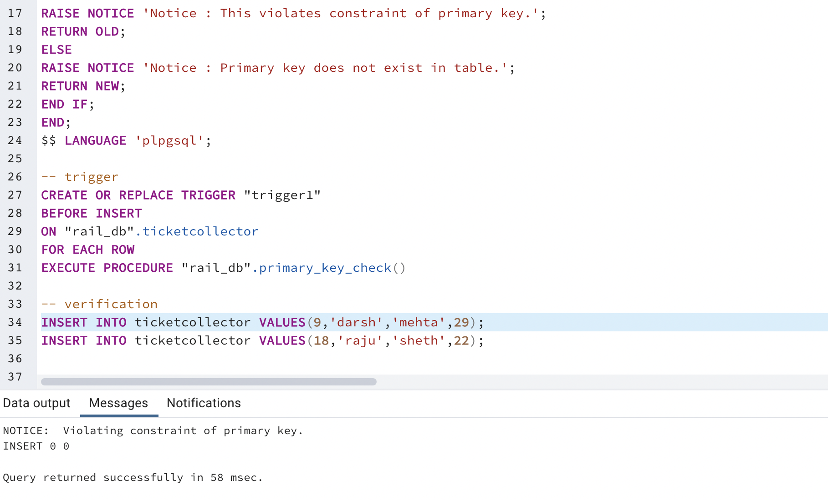

provided tc_id (primary key) is already present in table, hence it will not be inserted.

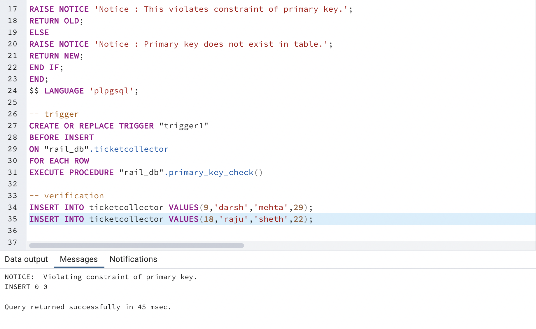

provided tc_id (primary key) is not present in table, hence it will not be inserted.

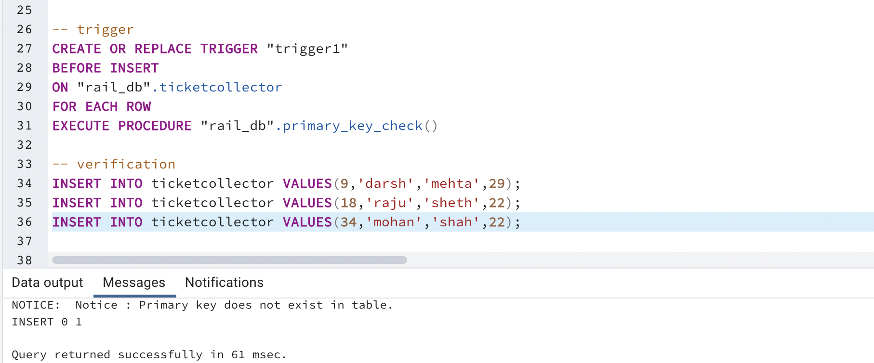

2. Create a trigger on the Table of your choice to check if the Foreign key ID already exists or not before inserting a new record. & Send a custom reply instead of an error message.

-- trigger function

CREATE OR REPLACE FUNCTION rail_db.foreign_key_check()

RETURNS trigger

AS $$

DECLARE

temp_id integer;

BEGIN

SELECT tc_id into temp_id from rail_db.train t1 where t1.tc_id=NEW.tc_id;

IF(temp_id=NEW.tc_id)

THEN

RAISE NOTICE 'Notice : Foreign key already exists in this table.';

RETURN OLD;

ELSE

RAISE NOTICE 'Notice : Foreign key is not present in this table.';

RETURN NEW;

END IF;

END;

$$ LANGUAGE 'plpgsql';

-- trigger

CREATE OR REPLACE TRIGGER "trigger2"

BEFORE INSERT

ON "rail_db".train

FOR EACH ROW

EXECUTE PROCEDURE "rail_db".foreign_key_check()

--verification

INSERT INTO train VALUES(201,'Rajdhani Express','10:21:00','02:30:00',12,'2022-08-11',14);

INSERT INTO train VALUES(202,'Vikas Express','09:05:00','04:30:00',12,'2022-08-11',31);

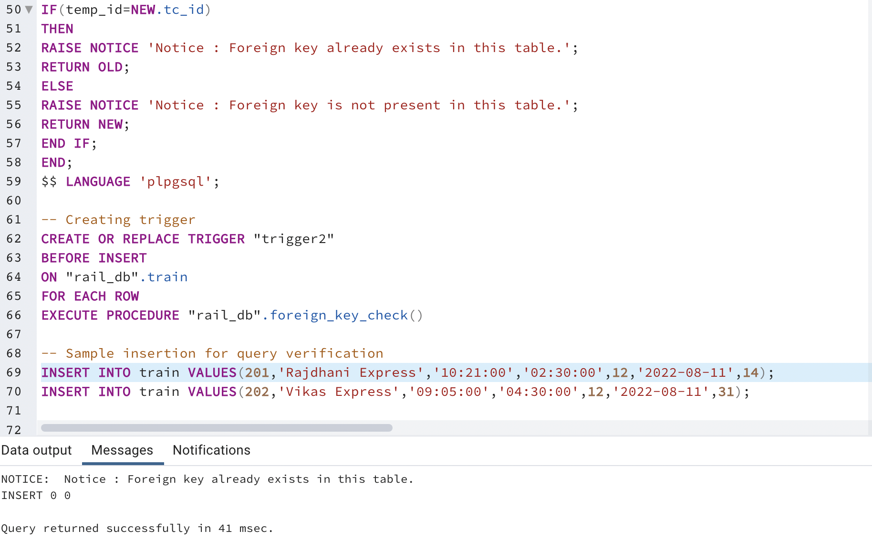

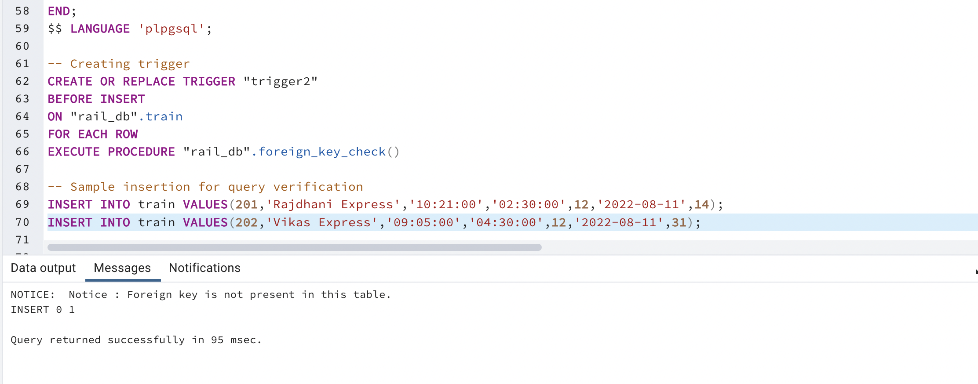

**II. Create functions for a specific section.**

1. Find the ticket id for an amount greater than 2000. Return a temp table with ticket id, amount and status in the result table. Make sure below both records are visible in results.

--tickets with id greater than 2000

SELECT ticket_id FROM ticket WHERE amount>2000 ORDER BY ticket_id;

--trigger function

CREATE OR REPLACE FUNCTION rail_db.func_temp1_Q2()

RETURNS TABLE(a integer, b integer , c character(30))

AS $$

DECLARE

TEMP_R_LIST record;

BEGIN

CREATE TEMP TABLE test (a1 integer, b1 integer, c1 character(30)) ON COMMIT DROP;

FOR TEMP_R_LIST IN (select ticket_id,amount,status from rail_db.ticket)

LOOP

IF(TEMP_R_LIST.amount>2000)

THEN

INSERT INTO test (a1, b1, c1) VALUES (TEMP_R_LIST.ticket_id,TEMP_R_LIST.amount,TEMP_R_LIST.status);

END IF;

END LOOP;

RETURN QUERY TABLE test;

END;

$$ LANGUAGE 'plpgsql';

SELECT ALL rail_db.func_temp1_Q2()

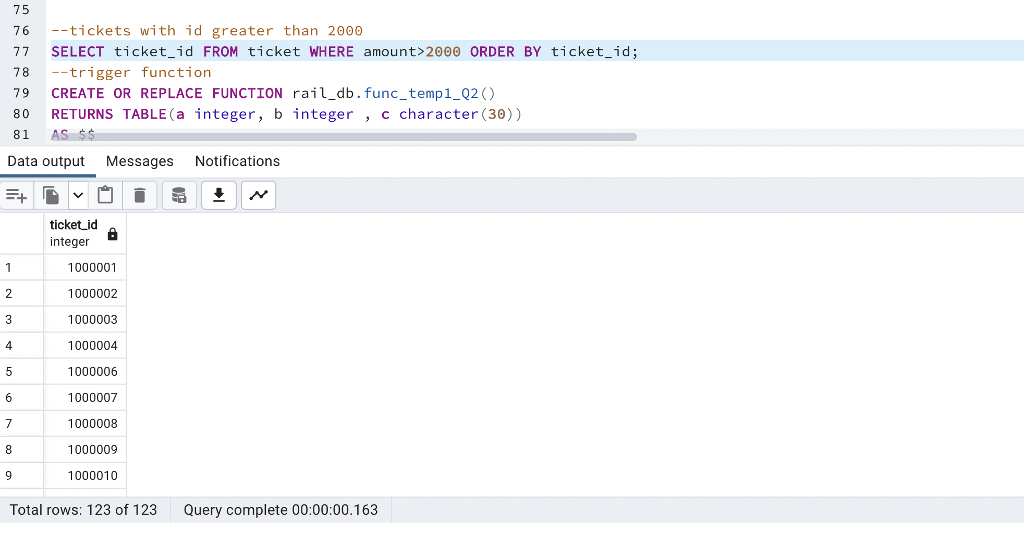

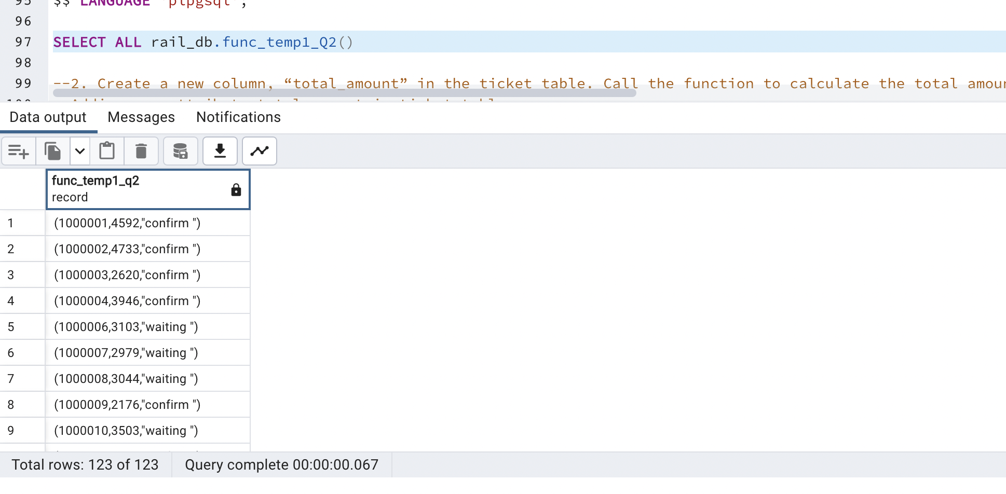

2. Create a new column, “total_amount” in the ticket table. Call the function to calculate the total amount with the formula amount+0.12*amount. Display the updated table.

-- new attribute total_amount

ALTER TABLE ticket ADD total_amount decimal(7,2);

-- trigger function

CREATE OR REPLACE FUNCTION rail_db.func_temp2_Q2()

RETURNS void

AS $$

DECLARE

TEMP_R_LIST record;

BEGIN

FOR TEMP_R_LIST IN (select ticket_id,amount,total_amount FROM rail_db.ticket)

LOOP

UPDATE rail_db.ticket

SET total_amount= TEMP_R_LIST.amount + 0.12*TEMP_R_LIST.amount WHERE TEMP_R_LIST.ticket_id=ticket_id;

END LOOP;

END;

$$ LANGUAGE 'plpgsql';

SELECT rail_db.func_temp2_Q2();

SELECT * FROM ticket ORDER BY ticket_id;

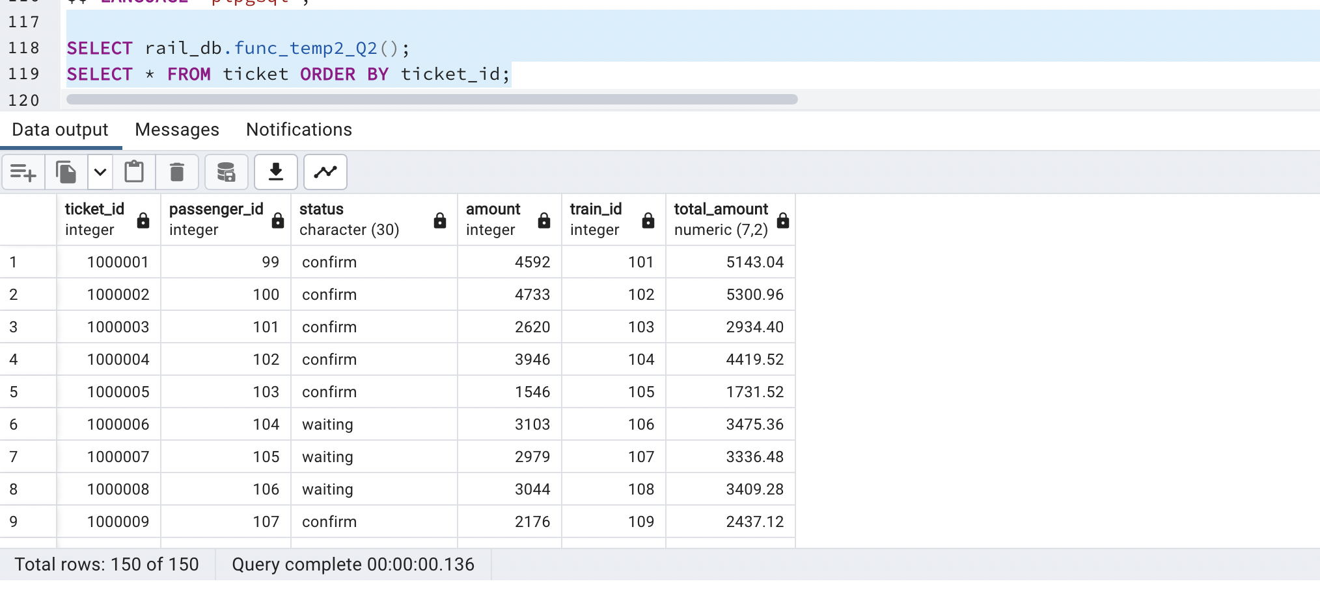

**III. Create Trigger functions for a specific section.**

1. Create a column “state” in the station table. Create a trigger to put the default value 1 for every new entry if nothing is given by the user. Insert new records and check the functionality of Triggers.

-- new attribute state

ALTER TABLE station ADD state INTEGER

-- trigger function

CREATE OR REPLACE FUNCTION rail_db.state_update()

RETURNS trigger

AS $$

DECLARE

temp_state int;

BEGIN

SELECT state INTO temp_state from rail_db.station s where s.station_id=NEW.station_id and state is not null;

update station set state=1 where NEW.station_id=station_id;

if(temp_state<>1) then update station set state=temp_state WHERE NEW.station_id=station_id;

end if;

return new;

END;

$$ LANGUAGE 'plpgsql';

-- trigger

CREATE OR REPLACE TRIGGER "t3"

AFTER INSERT

ON rail_db.station

FOR EACH ROW

EXECUTE PROCEDURE rail_db.state_update();

INSERT INTO station VALUES(103,'BM6 HGF','09:15:00',202,'Yes');

INSERT INTO station VALUES(101,'BHF H68','11:15:00',202,'Yes',5);

SELECT * FROM station

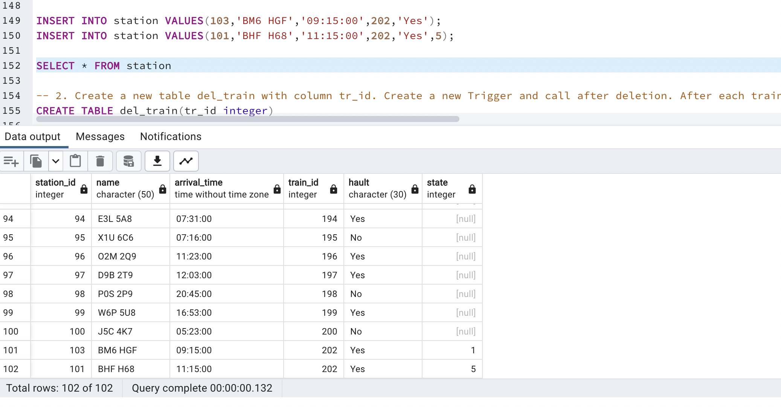

2. Create a new table del_train with column tr_id. Create a new Trigger and call after deletion. After each train deletion it should enter the tr_id to the del_train table. Check for at least 3 records and print the del_train table.

CREATE TABLE del_train(tr_id integer);

-- trigger function

CREATE OR REPLACE FUNCTION rail_db.train_backup()

RETURNS TRIGGER

AS $$

BEGIN

INSERT INTO del_train VALUES(OLD.train_id);

RETURN OLD;

END;

$$ LANGUAGE 'plpgsql';

-- trigger

CREATE OR REPLACE TRIGGER "trigger_train_backup"

AFTER DELETE

ON train

FOR EACH ROW

EXECUTE PROCEDURE rail_db.train_backup();

--Inserting some extra data

INSERT INTO train(train_id,tc_id) VALUES(201,4),(202,2),(203,8),(204,9),(205,11);

--Deleting data from train

DELETE FROM train WHERE train_id=201;

SELECT * FROM rail_db.del_train;

DELETE FROM train WHERE train_id=202;

SELECT * FROM rail_db.del_train;

DELETE FROM train WHERE train_id=204;

DELETE FROM train WHERE train_id=205;

SELECT * FROM rail_db.del_train;

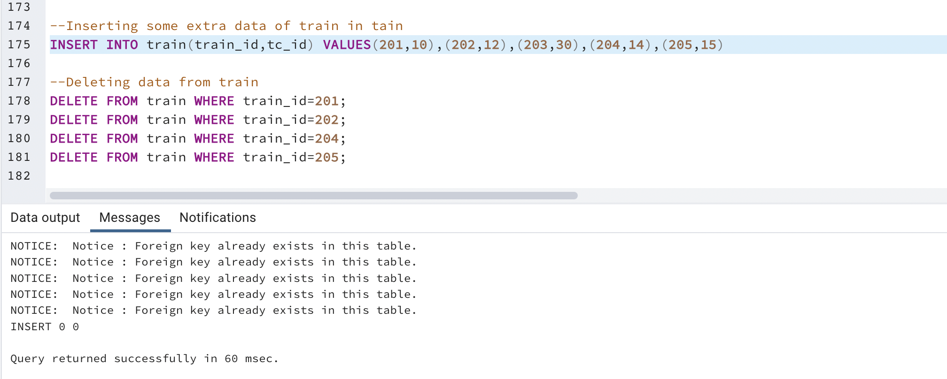

Delete train with train_id 201 :-

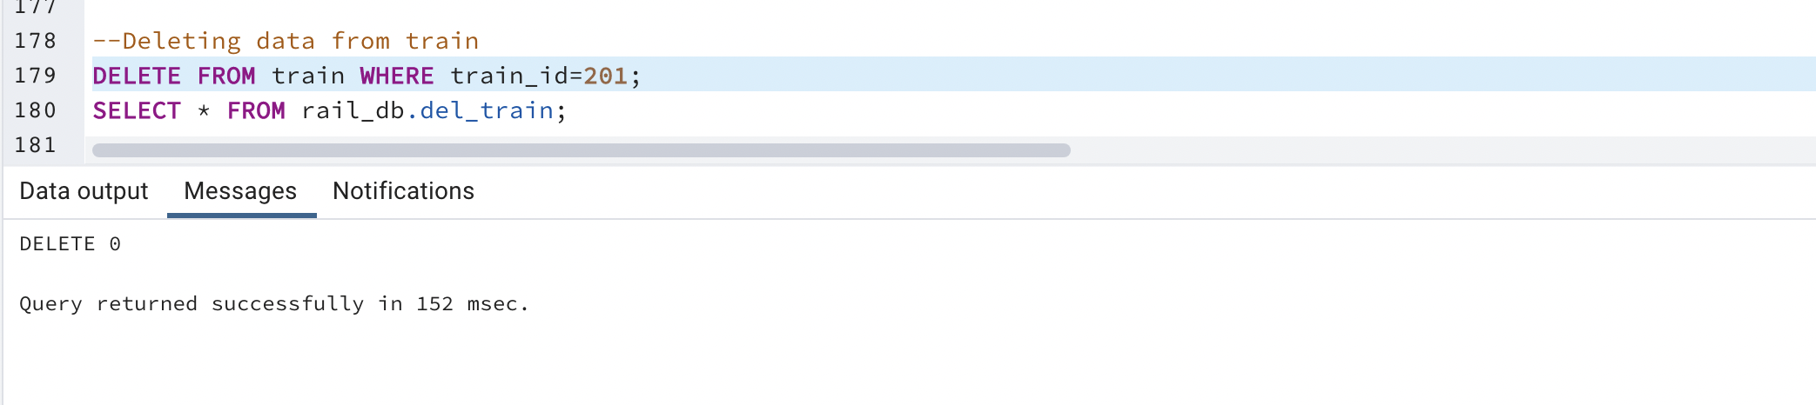 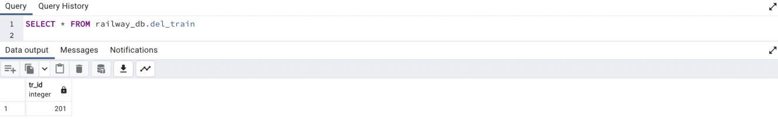

Delete train with train_id 202 :-

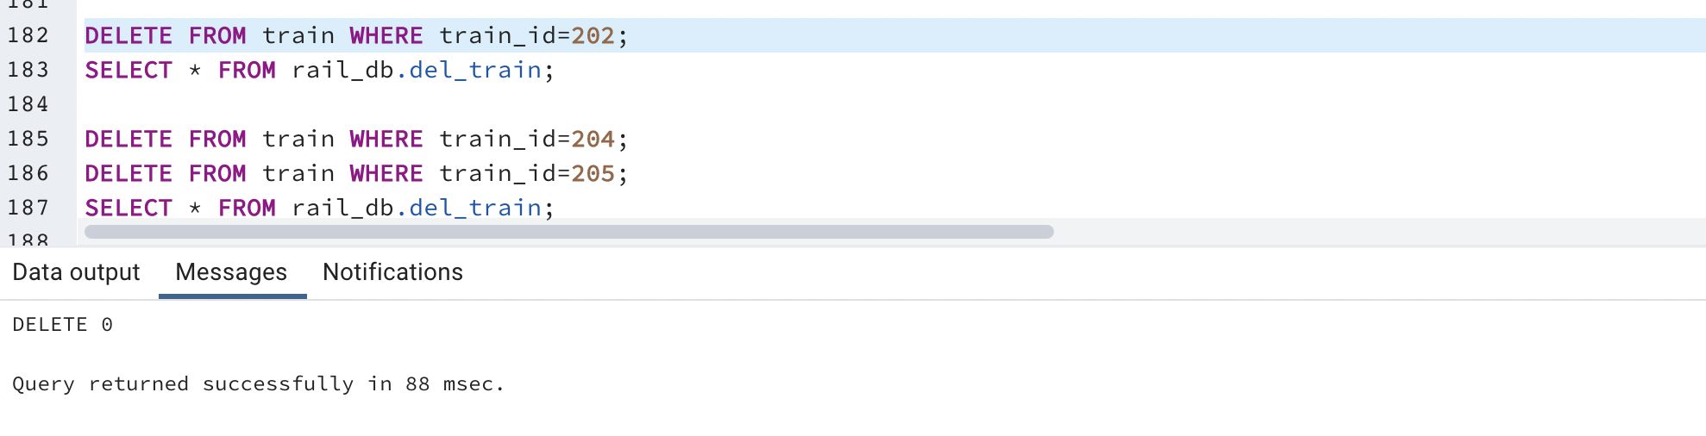 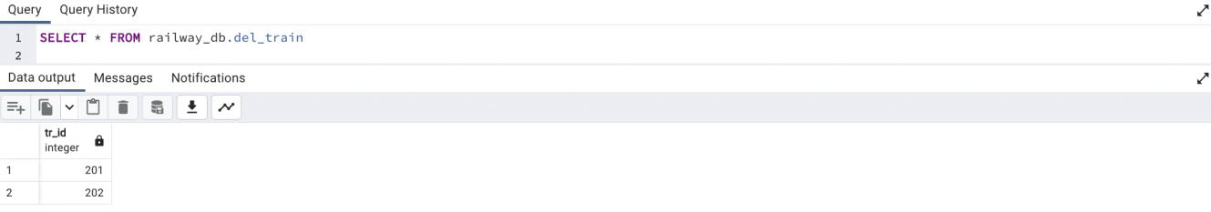

Delete train with train_id 204 and 205 :-

